# CAPSTONE PROJECT REPORT (PAT INTERN)

*Submitted in partial fulfillment for the award of the degree of*

## B.TECH IN ELECTRONICS AND COMMUNICATION ENGG

## (sp. IN IOT AND SENSORS )

*by*

**ESHANEE GHOSH (17BIS0079)**



**SCHOOL OF ELECTRONICS ENGINEERING (SENSE)**

June,2021

**DECLARATION**

I hereby declare that the thesis entitled “CAPSTONE PROJECT REPORT (PAT INTERN)” submitted by me, for the award of the degree of B.Tech in Electronics and Communication Engg (sp.in IOT and Sensors) to VIT is a record of bonafide work carried out by me under the supervision of Mohit Sehgal (Manager).

I further declare that the work reported in this thesis has not been submitted and will not be submitted, either in part or in full, for the award of any other degree or diploma in this institute or any other institute or university.

Place: Vellore 

Date: 29/05/2021

Signature of the Candidate

**PROOF OF EMPLOYMENT**

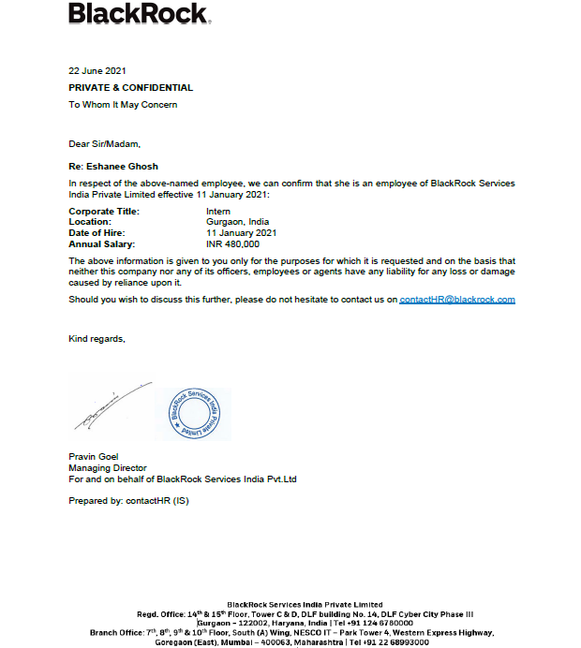

**ABSTRACT**

The role of information technology in various sectors has evolved quickly since the last decade of the 20th century. Modern organizations use information technology throughout most, if not all, departments and across most functions. Internet revolution has introduced number of advanced technologies to access organizations all over the world in an efficient but simple manner. But IT goes far beyond mundane operations.

The right IT systems give companies a competitive edge, enabling them to enter larger markets and expand products or service lines more efficiently, as well as keep tabs on competitors. IT has now become such a pervasive aspect of business operations that many employees and managers no longer see it as a separate function. Rather, IT has become an indispensable element of every corporate department and function, driving innovation and fostering growth throughout the entire organization.

Information technology in business helps a corporation maintain a watchful eye on expenses and profits, enabling management to act more nimbly to trim costs or to change the sales team’s focus when necessary. A strong IT system also helps all facets of a company work more productively. By enabling automation and digital tools, tasks that once took hours can now be performed in a matter of minutes. Today’s agile businesses weave IT into everything they do, enabling them to accomplish more in a shorter amount of time.

**ACKNOWLEDGEMENT**

It is my pleasure to express with deep sense of gratitude to Mohit Sehgal, for his constant guidance, continual encouragement, understanding; more than all, he taught me patience in my endeavor. My association with him is not confined to academics only, but it is a great opportunity on my part of work with an intellectual and expert in the field of Telemetry.

I would like to express my gratitude to Dr. G. Viswanathan,

Mr. G.V.Selvam, Dr. Rambabu Kodali, Dr. S. Narayanan and

Dr. Kittur Harish Mallikarjun, School Of Electronics Engineering

(SENSE), for providing with an environment to work in and for his

inspiration during the tenure of the course.

In jubilant mood I express ingeniously my whole-hearted thanks to Electronics and Communication Engg. sp. In IOT and Sensors, Dr. Sasikumar P, all teaching staff and members working as limbs of our university for their not-self-centered enthusiasm coupled with timely encouragements showered on me with zeal, which prompted the acquirement of the requisite knowledge to finalize my course study successfully. I would like to thank my parents for their support.

It is indeed a pleasure to thank my friends who persuaded and encouraged me to take up and complete this task. At last but not least, I express my gratitude and appreciation to all those who have helped me directly or indirectly toward the successful completion of this project.

Place: Vellore Eshanee Ghosh

Date: 29/05/2021 Name of the student

## CONTENTS

SNO. TOPICS PAGE

1. INTRODUCTION 7-8
2. STUDY MATERIALS 9
3. AJDC 10-24
4. PROJECT-X 25-55
5. INTERN PROJECT 56-68
6. ADDITIONAL TASKS & FUN ACTIVITIES 69
7. CONCLUSION 70
8. REFERENCES 71

**CHAPTER 1**

**INTRODUCTION TO BLACKROCK**

BlackRock, Inc. is an American multinational investment management corporation based in New York City. Founded in 1988  by Larry Fink, Robert S. Kapito, Susan Wagner, Barbara Novick, Ben Golub, Hugh Frater, Ralph Schlosstein, and Keith Anderson, initially as a risk management and fixed income institutional asset manager, BlackRock is the world's largest asset manager, with $8.67 trillion in assets under management as of January 2021.BlackRock operates globally with 70 offices in 30 countries and clients in 100 countries.

Blackrock offers a range of solutions for institutions, financial professional and individuals across the globe. From shop assistants in the local stores to national organizations and non-profits, Blackrock has helped people take control of their financial security for over three decades. The purpose is to help more and more people experience financial well-being. Together with the clients, the aim is to contribute to a more equitable and resilient world-today and for generations to come.

The firm offers a variety of funds and portfolios investing in vehicles such as equities, money market instruments, and fixed income. Clients look to BlackRock for access to mutual funds, investments focused on objectives related to retirement income and college savings, and exchange traded funds. BlackRock is the parent company for the iShares group of ETFs, the largest global provider of ETFs. BlackRock reports as a single business segment, derivingthe majority of its revenue from investment advisory and administrative fees charged to its clients.

Here’s a glimpse of Blackrock’s Revenue Breakdown:

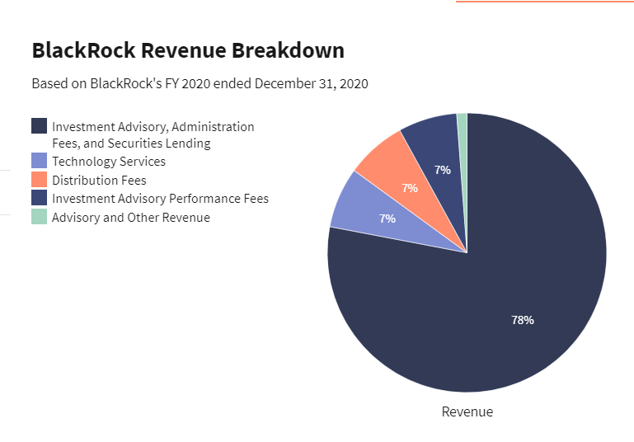

**CHAPTER 2**

**STUDY MATERIALS**

Pluralsight, Inc. is an American publicly held online education company that offers a variety of video training courses for software developers, IT administrators, and creative professionals through its website. Founded in 2004 by Aaron Skonnard, Keith Brown, Fritz Onion, and Bill Williams, the company has its headquarters in Farmington, Utah. As of July 2018, it uses more than 1,400 subject-matter experts as authors, and offers more than 7,000 courses in its catalog. Since first moving its courses online in 2007, the company has expanded, developing a full enterprise platform, and adding skills assessment modules.

Blackrock uses this technology learning platform to provide skill-building opportunities to stay current with the changing pace of technology and develop new skills to grow the learner’s career. Plural Sight has worked with internal experts to develop customized learning paths focused on the technical skills necessary at Blackrock.

The entire process of learning was divided into several Developer Training Program Sessions based on day-to-day basis. We had to join different channels, go through the study materials, attend tests and quizzes and complete the courses in the due course of time. The major technologies focused during these learning sessions were: Java fundamentals, Building API’s, JDBC, Exception Handling , Introduction to Spring Framework and SpringBoot etc.

Apart from PluralSight courses, we were also asked to complete Compliance Training Courses which included learning about the Blackrock’s financial, technical, and familiarizing with the work culture of Blackrock along with their privacy policies and many more.

All in all, the entire learning sessions were very informative and helped us to have an all-round idea and knowledge of the Blackrock’s work culture and prepared us for the upcoming challenges and projects.

**CHAPTER 3**

**ALADDIN JAVA DEVELOPER’S CERTIFICATION (AJDC)**

3.1 WHAT IS ALADDIN?

Aladdin (Asset, Liability, Debt and Derivative Investment Network) is an electronic system by BlackRock Solutions, the risk management division of the largest investment management corporation, BlackRock, Inc. In 2013, it handled about $11 trillion in assets (including BlackRock's $4.1 trillion assets), which was about 7% of the world's financial assets, and kept track of about 30,000 investment portfolios.As of 2020, Aladdin managed $21.6 trillion in assets.

Aladdin has always been at the core of BlackRock. It was first built to manage BlackRock’s business, and the firm continues to be the largest user of Aladdin today. Through Aladdin, the firm offers to clients the same technology and intellectual capital that BlackRock uses to manage investments day-to-day.

More than investment software, Aladdin technology brings clarity and connectivity to the world’s financial ecosystem. Everything they do is guided by the conviction that investors need this clarity at every point in the investment process in order to make more informed decisions, scale efficiently and achieve better investment outcomes. In pursuit of this goal, they are relentlessly innovating and constantly evolving Aladdin technology.

3.2 INTRODUCTION TO AJDC

The Aladdin Java Developer Certification is a training program that aims to helps one to go from a Java Developer to an Aladdin developer.

It took us through 3 stages (Bronze,Silver,Gold) of building up an application to get us familiarize with the standard Java and Aladdin technologies used in APG. By the end of it, we were supposed to be in a great position to kick start our development in any Aladdin team!

The aim of the tasks is to take us through the life-cycle of building a Blackrock application from scratch, whilst introducing some core business terms and ideas.

3.2.1 PRE-REQUISITES:

1. AQUA DATA STUDIO(ADS)

Aqua Data Studio is a universal integrated development environment (IDE) for databases and visual analytics. It enables database developers, database administrators, and data and business analysts to handle their multi-platform databases and the data contained therein. Develop, manage, and administer databases; access, manage, and visually analyze data; and connect to a large range of relational, cloud, and NoSQL database platforms.

BENEFITS OF ADS

* Use a single database tool to manage many tasks for numerous data sources
* Easily develop, execute, and share SQL statements
* View, filter, and edit query results in Excel-like grid with copy-and-paste
* Create visualizations and dashboards to analyze data with drag-and-drop
* Compare schema, data, query results, files, and folders
* Reverse-engineer databases into entity relationship diagrams

1. INTELLIJ IDEA

IntelliJ IDEA is an Integrated Development Environment (IDE) for JVM languages designed to maximize developer productivity. It does the routine and repetitive tasks for you by providing clever code completion, static code analysis, and refactorings, and lets you focus on the bright side of software development, making it not only productive but also an enjoyable experience.

JVM LANGUAGES SUPPORTED

* Java
* Kotlin
* Scala
* Groovy

WHY INTELLIJ IDEA?

IntelliJ IDEA analyzes your code, looking for connections between symbols across all project files and languages. Using this information it provides indepth coding assistance, quick navigation, clever error analysis, and, of course, refactorings.

1. GIT REPOSITORY:

Git is software for tracking changes in any set of files, usually used for coordinating work among programmers collaboratively developing source code during software development. Its goals include speed, data integrity, and support for distributed, non-linear workflows.

Repositories in GIT contain a collection of files of various different versions of a Project. These files are imported from the repository into the local server of the user for further updations and modifications in the content of the file. A VCS or the Version Control System is used to create these versions and store them in a specific place termed as a repository. The process of copying the content from an existing Git Repository with the help of various Git Tools is termed as **cloning.** Once the cloning process is done, the user gets the complete repository on his local machine. Git by default assumes the work to be done on the repository is as a user, once the cloning is done.  
Users can also create a new repository or delete an existing repository. To delete a repository, the simpler way is to just delete the folder containing the repository.

WHY GIT

* Speed
* Simplicity
* Fully Distributed
* Excellent support for parallel development, support for hundreds of parallel

branches.

* Integrity

1. AZURE DEVOPS

Azure DevOps Server (formerly Team Foundation Server (TFS) and Visual Studio Team System (VSTS)) is a Microsoft product that provides version control (either with Team Foundation Version Control (TFVC) or Git), reporting, requirements management, project management (for both agile software development and waterfall teams), automated builds, testing and release management capabilities. It covers the entire application lifecycle, and enablesDevOps capabilities.Azure DevOps can be used as a back-end to numerous integrated development environments (IDEs) but is tailored for Microsoft Visual Studio and Eclipse on all platforms.

WHY ADO?

* Ease in Collaboration
* Provision of adding work items
* Continuous Integration and Delivery
* Open Platform

1. JIRA

## **JIRA** is a tool developed by Australian Company Atlassian. This software is used for **bug tracking, issue tracking,** and **project management**. The JIRA full form is actually inherited from the Japanese word "Gojira" which means "Godzilla". The basic use of this tool is to track issue and bugs related to your software and Mobile apps.

Jira Software is part of a family of products designed to help teams of all types manage work. Originally, Jira was designed as a bug and issue tracker. But today, Jira has evolved into a powerful work management tool for all kinds of use cases, from requirements and test case management to agile software development.

It is also used for project management. The JIRA dashboard consists of many useful functions and features which make handling of issues easy.

WHY JIRA?

* Requirements and Test case management
* In Agile Methodology
* Project Management
* Software Development
* Product Management
* Task Management
* Bug Tracking

3.2.2 BUSINESS PROBLEM STATEMENT:

We want to find all the distinct CUSIPs for which there is an open position on the prior business day for a specified portfolio.

CUSIP stands for Committee on Uniform Securities Identification Procedures. A CUSIP number identifies most financial instruments and can represent an asset.

A portfolio is a grouping of financial assets.

An open position in investing, is any trade, established or entered, that has yet to be closed with an opposing trade. An open position can exist following a buy or long position or a sell or short, position of an asset. In either case, the position remains open until an opposing trade takes place.

An asset is a resource with economic values that an individual, corporation or country owns or controls with the expectation that it will provide future benefit.

3.2.3 AJDC BRONZE:

COVERS:

* Getting familiar with databases used at BlackRock by using Aqua Data Studio (a database query and administration tool)
* Getting familiar with at least one IDE (Eclipse/IntelliJ).
* Getting an understanding of GIT Workflows used within BlackRock and the workflow used in your team(discuss it with your team)
* Ability to understand and develop a solution for a business problem.
* Learning how to use the tools for the Aladdin SDLC (Jira, GIT - used with BitBucket)

GOALS:

* Identifying the different entities in the business problem description.
* Implementing JAVA classes and attributes for them that are required to solve the business problem
* Implementing methods to create portfolios and add positions to them in your java program
* Creating a portfolio in the main method of your program
* Using a database query tool (Aqua Data Studio) construct a query to retrieve the desired data, and add them to your portfolio.*

POJOs

Creating POJOs (Plain Old Java Objects) that identifies the entities in the business problem using information from the database documentation and the database query tool using ADS (Aqua Data Studio) to query the tables and find out what columns we need to use.

PORTFOLIOS AND POJOs

* In the main method we had to create two portfolios which contain five positions each.
* Ensuring that the portfolios we create have a couple of open positions in the positions we have created.
* Using the tables for examples as to what data should be in these objects.
* Running our program which should print out a list of cusips for respective portfolio in the format shown below.

{portfolio1's name} : {distinct cusips for portfolio1} | {portfolio2's name} : {distinct cusips for portfolio2}

* Writing Unit Tests to check your methods.
* Once completed, commit to your branch within your GIT repository.

SUCCESS CRITERIA

• Main implementation:

* Having a working project which complies in our chosen IDE and correctly outputs a list of cusips for which there is an open position on the prior business day, for any given Portfolio that has been created.
* The code should have a clear layout, with appropriately named fields, attributes and classes.
* Demonstrating methods that will make effective use of parameters (no unnecessary duplication of methods).

• Tests:

* Having unit tests which covers all our methods.

3.2.4 AJDC SILVER

COVERS:

Developing a Java application using SpringBoot.

Getting familiar with a dependency management tool (Maven)

Getting familiar with Spring Concepts and set up Spring configuration from scratch

Enhancing our Bronze submission by working with Aladdin Databases and real data

Map databases entities to Java objects, using an ORM utility

Ability to use BlackRock Wiki to search for relevant information

GOALS:

Building on top of our AJDC Bronze project, our program will:

* Connect to the database
* Return a list of all distinct cusips for which there is an open position on the prior business date in a specified portfolio group. The portfolio group will be passed in as an argument to the program.
* The user must have permission to view this portfolio group in order to get any results.
* Permissions API
* Preventing SQL Injections and checking for illegal characters in the program arguments (a portfolio group name can only contain alphanumeric characters, underscores and dashes).

ASSIGNMENT:

* Creating a SpringBoot Aplication- where all our following logic will go
* Utilizing the BlackRock library for the datasource connection
* Utilising an ORM utility to map database entities to Java objects.
* Returning a list of all distinct cusips for which there is an open position on the prior business date in a specified portfolio group.
* The user must have permission to view this portfolio group in order to get any results.
* Preventing SQL Injections and checking for illegal characters in the program arguments (a portfolio group name can only contain alphanumeric characters, underscores and dashes).
* Adding DBUnit tests for your chosen ORM implementation

DEPENDENCY MANAGEMENT: A dependency is essentially when our project refers to another project, or library. Previous employees at BlackRock have put a lot of effort into developing re-usable libraries which perform many tasks that are commonly repeated in different projects. Managing dependencies in large projects, can quickly become difficult. Especially when, for example, the libraries themselves are still being developed. It is not uncommon in this development environment to see libraries quickly upgrade between versions.

SUCCESS CRITERIA

* + - Main implementation:
* Successfully implementing the application by using the Spring framework and retrieved data from Aladdin databases.
* Using dependency management.
* Good encapsulation, loose coupling.
* Good method / attribute naming standards.
* Showing sufficient logging.
* Showing sufficient exception handling.

• Tests:

* Unit tests should be in memory only and not have external connections.
* Any tests that do have external connections should be clearly separated by another package or test suite

3.2.5 AJDC GOLD

COVERS:

* Enhancing submission for Silver by supporting two methods of accessing positions data; BMS and HTTP
* Making our code Production ready (logging and exception handling)

GOALS:

Building on top of our AJDC Silver project, our program will be enhanced with the:

* Ability to learn popular technologies used at BlackRock like SpringBoot
* Ability to get your server to handle HTTP requests and parse JSON results

ASSIGNMENT:

* Adding the classes to handle the following:1. BMS messages:§ Adding the required handlers to our SpringBoot application effectively making it a proper server§ Testing the server by creating a Client and calling this, print out the result.2. HTTP requests: § Using the Spring framework to create a HTTP handler in the server.§ A HTTP request should be able to retrieve open positions for given portfolio in JSON format§ Parsing the JSON back into Position objects and print them out
* Ensuring the requirement from Silver 'The user must have permission to view this portfolio group in order to get any results.' still applies when a user sends a BMS or HTTP request for data.

DEPENDENCY MANAGEMENT:

* Creating a Swing UI o Developing an Aladdin User interface using Swing and AMTable

o Application will communicate with our server.

* Creating a web interface o Developing a web application using Angular2, Blk-bootstrap, BMS.js, AladdinBrowsero Application will communicate with your server using BMS.js

SUCCESS CRITERIA:

* Main implementation:
* Good encapsulation, loose coupling
* Good method / attribute naming standards
* Showing sufficient logging e.g.positions retrieved, JSON result to be sent to client
* Showing sufficient exception handling
* Test:
* A BMS handler test which calls our Client to retrieve open positions for a given portfolio
* A HTTP handler test which sends a HTTP request with a given portfolio argument, receives a JSON

3.2.6 AJDC GOLD ADDITIONAL TASK

The task was to display the metrics obtained from the AJDC Gold Task and display it

on the Grafana Dashboard.

WHAT IS GRAFANA?

A Grafana dashboard is a powerful open source analytical and visualization tool that consists of multiple individual panels arranged in a grid. The panels interact with configured data sources, including (but not limited to) AWS CloudWatch, Microsoft SQL server, Prometheus, MySQL, InfluxDB, and many others.

HOW DOES A GRAFANA DASHBOARD LOOK LIKE?

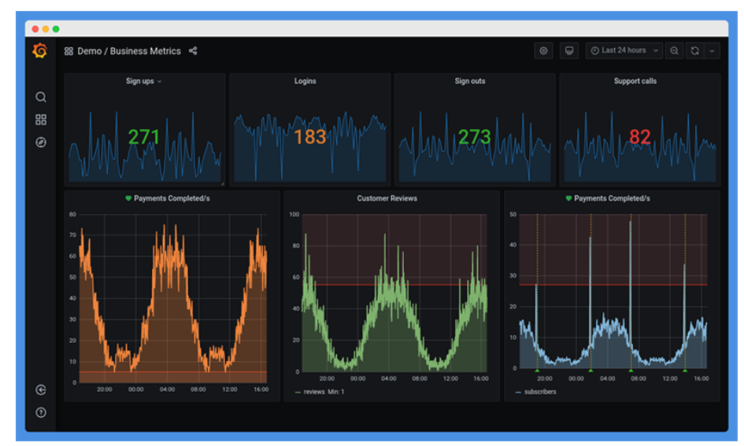

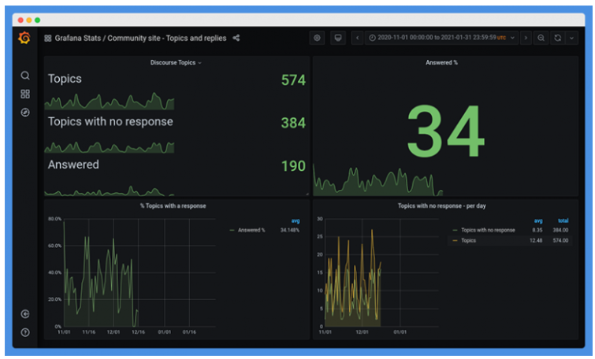

**CHAPTER 4**

**PROJECT -X**

4.1.1 PROBLEM STATEMENT

Predictive Content Personalization.

4.1.2 OBJECTIVE

* Identify how AI content personalization works. Explore various underlying ML methods for personalization like Regression, Reinforcement, Classification, Clustering, Personalization Algorithms, etc.
* Identify the suitable approach or a combination and build a recommender/personalizer solution for the implementation of the project.
* Identify other content frequently accessed by the users and customize the User Experience to show relevant personalized content.

4.1.3 DISCOVERY

APIs, or application program interfaces, are vital tools for businesses in all industries. The importance of APIs from a technical standpoint, they allow the capabilities of one computer program to be used by another.APIs have the potential to transform businesses. Traditional strategies rely on large sales forces, paperwork and other time-consuming, outdated and expensive measures to run their businesses, and the practice is becoming less sustainable all the time. Forward-thinking companies are reducing costs and time spent by “building their solutions with best-of-breed components, which they access via APIs,” according to Forbes. Sources of data1. Articles API2. News API3. Employee API4. Videos API

4.1.4 TECH STACK

* 1. ANGULAR

Angular is an open-source, JavaScript framework written in TypeScript. Google maintains it, and its primary purpose is to develop single-page applications. As a framework, Angular has clear advantages while also providing a standard structure for developers to work with. It enables users to create large applications in a maintainable manner.

Angular is a full-fledged model-view-controller (MVC) framework. It provides clear guidance on how the application should be structured and offers bi-directional data flow while providing real DOM.

ARCHITECTURE

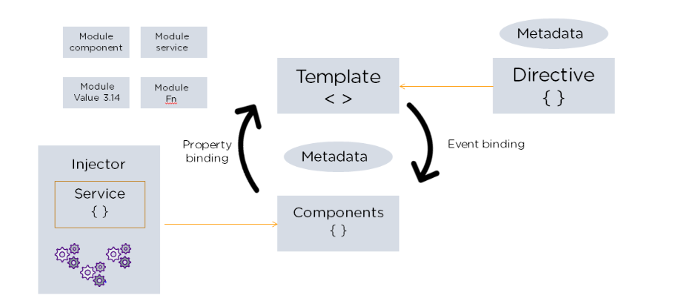

Advantages include:

* 1. Custom Components
  2. Data Binding
  3. Dependency Injection
  4. Testing
  5. Comprehensive

(f) Browser Compatibility

Limitations include:

* + 1. Steep Learning Curve
    2. Limited SEO Options
    3. Migration
    4. Verbose and Complex
  1. PYTHON

In technical terms, Python is an object-oriented, high-level programming language with integrated dynamic semantics primarily for web and app development. It is extremely attractive in the field of Rapid Application Development because it offers dynamic typing and dynamic binding options.

Benefits include:

1. Easy to learn
2. Python can be used to develop prototypes, and quickly because it is so easy to work with and read.
3. It is the ideal language to work with for general purpose tasks.
4. Python allows for a more productive coding environment than massive languages like C# and Java
5. Python is easy to read, even if you’re not a skilled programmer. Plus, this makes it an ideal candidate for use among multi-programmer and large development teams.
6. Python powers Django, a complete and open source web application framework. Frameworks – like Ruby on Rails – can be used to simplify the development process.
7. It has a massive support base thanks to the fact that it is open source and community developed.

Limitations include:

* + - 1. Relatively slow speed than C/C++, Java
      2. Less compatible to mobile development
      3. Higher memory consumption
      4. Database access is difficult
      5. Runtime errors
  1. FLASK

Flask is a micro web framework written in Python. It is classified as a micro-framework because it does not require particular tools or libraries. It has no database abstraction layer, form validation, or any other components where pre-existing third-party libraries provide common functions.

Benefits include:

1. Minimalistic approach
2. The least amount of coding as compared to other frameworks.
3. No ORM in the delivery.
4. A debugger built right into the browser.
5. Routing URL is easy
6. Database integration is easy
7. High scalability for simple applications,
8. Higher compatibility with latest technologies

Limitations include:

1. Slower MVP development in most cases,
2. Higher maintenance costs for more complex systems
3. Complicated maintenance for larger implementations.
4. Async may be a little problem
5. Lack of database and ORM
6. Setting up a large project requires some previous knowledge of the framework
7. Offers limited support and smaller community compared to Django
   1. KIBANA

Kibana is an open-source data visualization and exploration tool used for log and time-series analytics, application monitoring, and operational intelligence use cases. It offers powerful and easy-to-use features such as histograms, line graphs, pie charts, heat maps, and built-in geospatial support. Also, it provides tight integration with Elastic search, a popular analytics and search engine, which makes Kibana the default choice for visualizing data stored in Elasticsearch.

Benefits include:

1. Interactive charts
2. Mapping support
3. Pre-built aggregations and filters
4. Easily accessible dashboards

Limitations include:

1. Adding of plugins to Kibana can be very tedious if there is version mismatch.
2. You tend to face issues when you want to upgrade from older version to a new one.
   1. ELASTIC SEARCH

Elasticsearch is a search engine based on the Lucene library. It provides a distributed, multitenant-capable full-text search engine with an HTTP web interface and schema-free JSON documents.

Benefits include:

1. High Performance
2. Easily Scalable
3. Distributed Architecture
4. Document-Oriented Database
5. Schema Free

Limitations include:

1. Sometimes, the problem of split-brain situations occurs in Elasticsearch.
2. Elasticsearch does not have multi-language support for handling request and response data.
3. Elasticsearch is not a good data store as other options such as MongoDB, Hadoop, etc.
4. It is a flexible and powerful data storage search engine, but it is a bit difficult to learn. Especially in terms of enterprise search usage, it is not as simplest as out the box search.

4.1.5 DIAGRAMMATIC REPRESENTATION

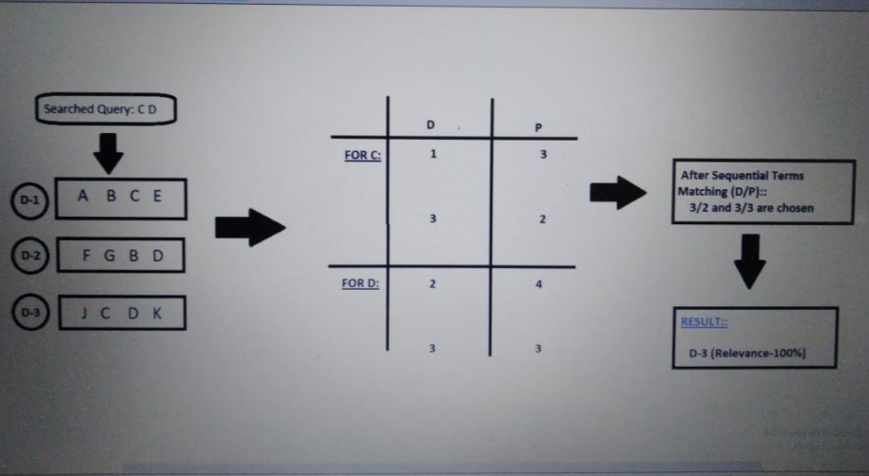

4.1.6 HOW WE ARE USING ELASTIC SEARCH?

* Let’s assume the user wants to search for words “C” & “D”. Here the alphabets inside these rectangular boxes are words & D-1, D-2 and D-3 are document numbers 1,2 and 3 respectively.
* Now, Elastic Search searches texts using indexes. So, the word “C, appears in document “1” at position “3” & in document “3” at position “2”. Likewise the word “D” appears in document “2” at position “4” and in document “3” at position ”3”.
* Next after sequential term matching out of these 4 pairs (3|2 &3|3) are chosen.
* So, the final result will display document “3“as it is 100% relevant to the user searched query since it has both the words.

4.1.7 WHY ELASTIC SEARCH?

* Can perform and combine various kinds of searches irrespective of their data type.
* Able to achieve fast search responses because instead of searching the text directly, it searches for an index instead.
* Supports full-text search and it is possible to analyze billions of records in a few seconds.

4.1.8 DATA PREPARATION

Data from Blackrock APIs is downloaded. As we are going to use these conversions of them to common and usable format is necessary. So, hence preprocessing i.e. data preparation for modelling is necessary. Data cleansing is a form of data management. Over time, individuals and businesses accumulate a lot of personal information! Eventually, information becomes outdated. Data cleansing is a process in which you go through all of the data within a database and either remove or update information that is incomplete, incorrect, improperly formatted, duplicated, or irrelevant (source). Data cleansing usually involves cleaning up data compiled in one areaData cleansing is so important for individuals because eventually, all this information can become overwhelming. Feature engineering is an essential process in data science to reap utmost benefits from the data available. Various methods of feature engineering aim at arriving at a coherent set of data that is comprehensible and easy to process for machine learning algorithms to obtain accurate and reliable results. Features affect the quality of output from machine learning algorithms and feature engineering aims at improving the features that go into training the algorithms. Converting articles, news and videos into common resource format Generalization of different resources and bringing all to a common resource format is very important to remove redundancy and decrease complexity in code.

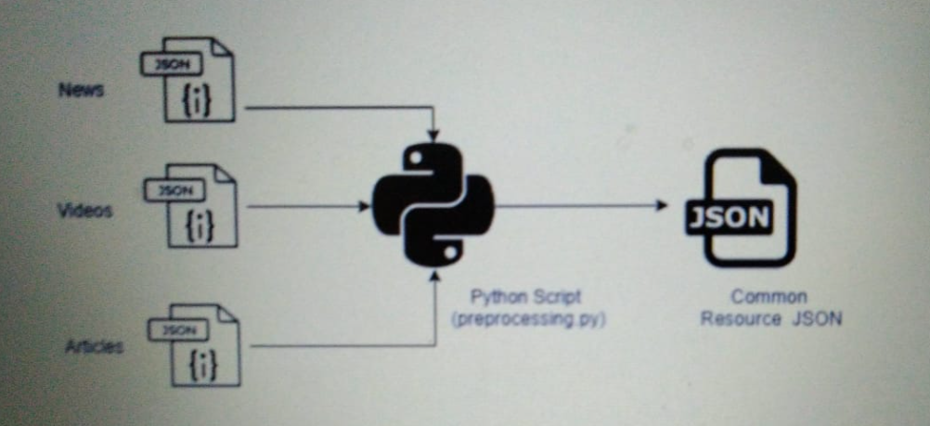

**Filtering Employees JSON**

Removing unnecessary fields from API ‘s data is very necessary to increase efficiency of searching and decreasing data size. This is improving time for searching and increase response time for our UI.

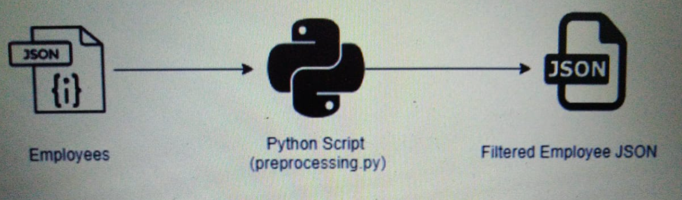

4.1.9 DATA MODELLING

ElasticSearch ML does is unsupervised learning time series analysis. That means it draws conclusions from a set of data instead of using training a model (i.e., supervised learning) to make predictions, like you would with regression analysis using different techniques, including neural networks, least squares, or support vector machines.

This is the familiar bell curve approach. Even if one does not think of it that way, that’s what they are doing. This curve is described by terms the high school math student should know mean, variance, and standard deviation.

Upload the Data into the Machine Learning Screens

All processed data must be uploaded to ElasticSearch which will search and return results for us when we hit it using python. All data uploaded into elastic search must be in JSON

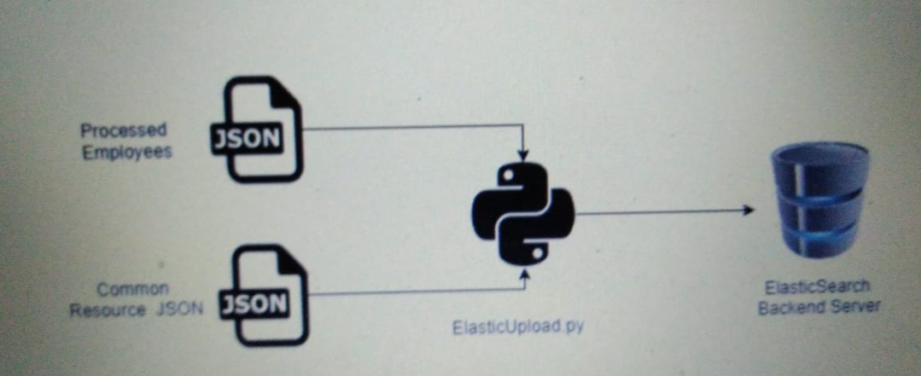

**Creation of Resource tags from Resources**

Every resource has lot of text. Keyword extraction (also known as keyword detection or keyword analysis) is a text analysis technique that automatically extracts the most used and most important words and expressions from a text. It helps summarize the content of texts and recognize the main topics discussed. Keyword extraction uses machine learning artificial intelligence (AI) with natural language processing (NLP) to break down human language so that it can be understood and analysed by machines.

It’s used to find keywords from all manner of text: regular documents and business reports, social media comments, online forums and reviews, news reports, and more With keyword extraction you can find the most important words and phrases in massive datasets in just seconds. And these words and phrases can provide valuable insights into topics your customers are talking about.Keywords Generator API helps finding and suggesting most important keywords in a text and ranking them. A relevance score is calculated for each keyword based on statistical analysis, and the results are returned sorted by relevancy. It uses the famous syntax net algorithm by Google and statistical analysis of text to retrieve important keywords from textual data.

We extract Skills, location, teams, author etc keywords from text and create a json that contains this information.Our Keyword Extractor successfully generates an extensive list of most relevant keywords and keyword phrases. It also makes keyword research process for Search engine optimization more context focussed.

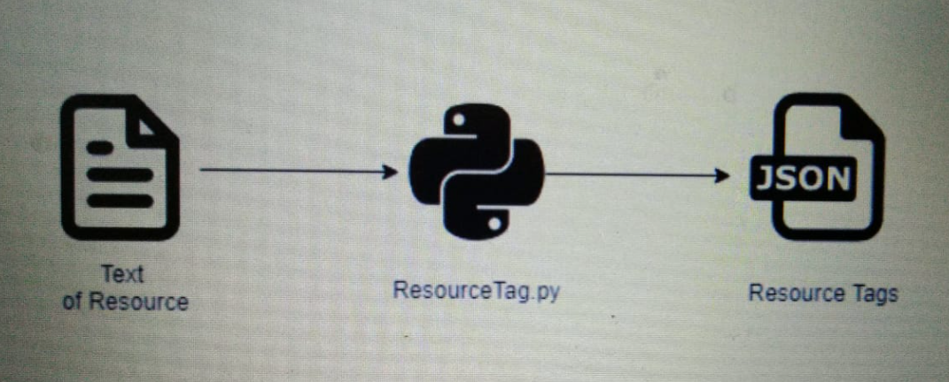

We will be missing is the Anomaly Detection, job creation, and other screens. Anomaly Detection, we want ElasticSearch to look currently series data. Pick the Single Metric option. Then we must create a job. ElasticSearch will run an aggregation query in the background.

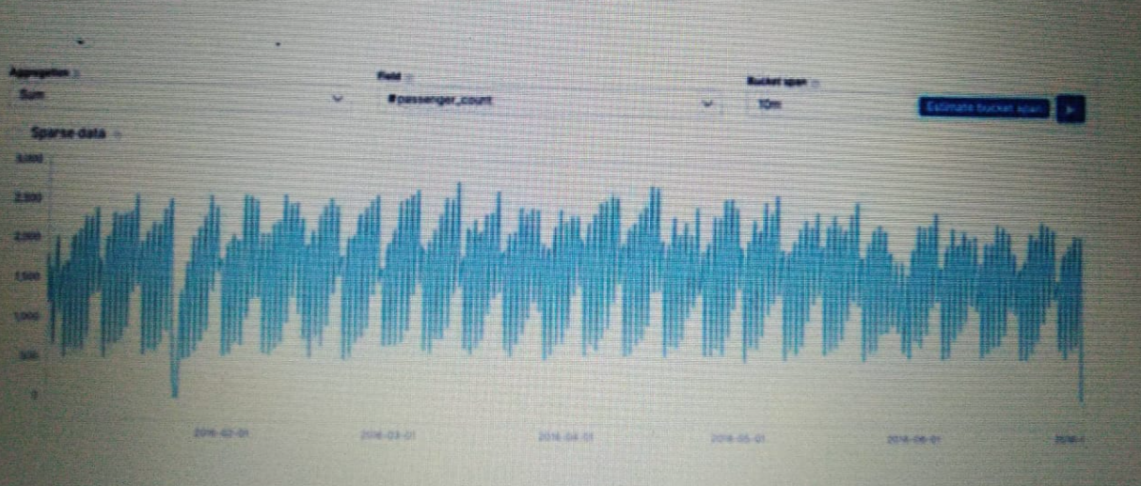

It starts running its algorithms and updating the display with vertical coloured lines as it completes its logic.



So, if we used a gaussian (normal) distribution against that it would be wrong, as the mean and variance would be over the whole set including the high and low points. So, the improved algorithm slides along making multiple normal curves (and other frequency distributions) against subsets of the data to eliminate this up and down pattern.

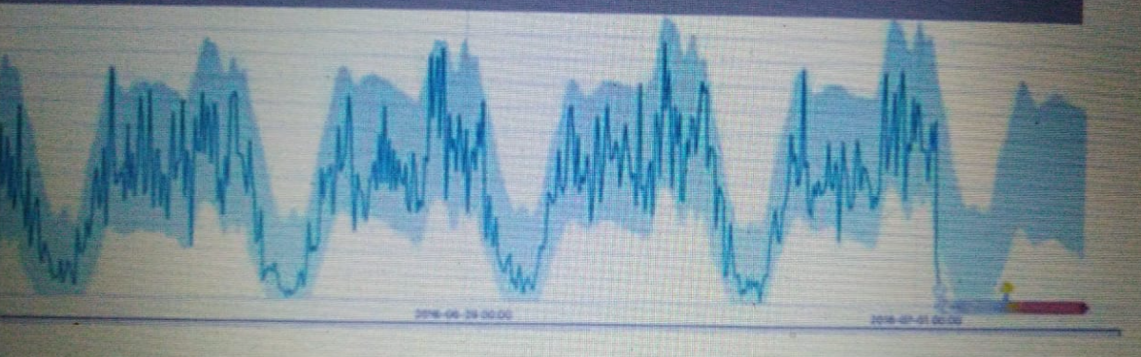

4.1.10 APPROACH (BACKEND)

Our aim was to build a search engine with a touch of personalization, so our approach was decided on the lines of this aim. Our main approach was decided after a lot of trial and error and availability of resources for achieving the task in hand.

Workflow of the project can be depicted in the following diagram

High level representation of our approach

So, our workflow consists of series of operations namely:

1. Full text Search
2. Ranking of Search results
3. Boosting of search results (Personalization Logic)

4.1.10.1 FULL TEXT SEARCH

In text recovery, full-text scan alludes to methods for looking through a solitary PC put away report or an assortment in a full-text information base. Full-text search is recognized from look through dependent on metadata or on pieces of the first messages addressed in data sets (like titles, abstracts, chosen areas, or bibliographical references).

In a full-text search, a web crawler looks at all the words in each put away archive as it attempts to coordinate with search measures (for instance, text indicated by a client). Full-text-looking through strategies got normal in online bibliographic information bases in the 1990s. Many sites and application programs, (for example, word preparing programming) give full-text-search capacities. Some web search tools, like AltaVista, utilize full-text-search strategies, while others file just a segment of the website pages analyzed by their ordering frameworks.

How it works?

For a small amount of simple textual data, it’s possible to provide basic search functionality via simple string matching. For example, using JavaScript you could store product data for a small online shop as an array of objects in a JSON file, then fetch the file and iterate over each object to find matches.

This simplistic approach can be better than nothing, but successful search needs more flexible functionality to find relevant results:

* **Stemming**: *developing for mobile*matches results for *develop for mobile* and vice versa.
* **Stopword handing**: Search engines need to avoid irrelevant results caused by matching common words such as *a* and *the.* (Conversely, ignoring stopwords can also cause problems for queries such as *The Who* or *To be or not to be*.)
* **Basic fuzzy matching**: *service workers* matches results for *Service Worker.*

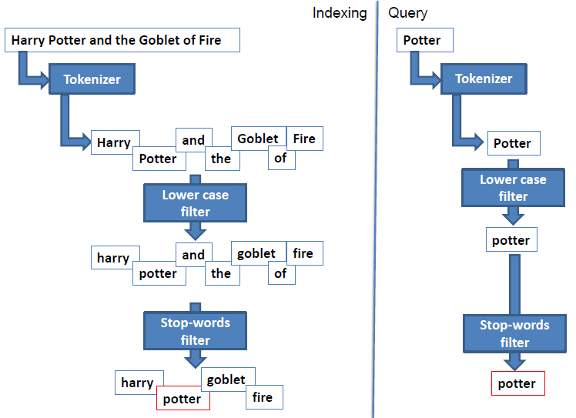

Full text Search Example

Most of the present-day search engine frameworks provide an abstraction over this process and save developers time in creating this from scratch. Some of the advantages using search engine framework is as follows:

* Speed: Using Full-text search guarantee speed in recovery of the outcomes for huge quantities of reports of an enormous book information base.
* Effectiveness: Accurate exact list items in all fields.
* Configurable inquiry standards and rationale.
* Static sites support: Many static sites utilize level records approach like JSON or Markdown organized documents. A few libraries and systems are utilizing
* Versatile applications support

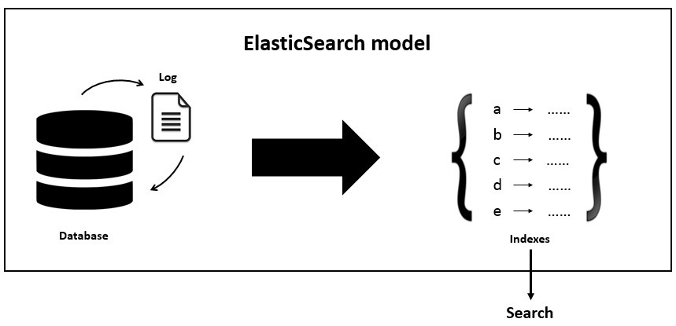

Frameworks add abstraction over comprehensive full text search process

How does elastic search implement full text search?

Elastic search implements the full text queries which enable you to search analyzed text fields such as the body of an email. The query string is processed using the same analyzer that was applied to the field during indexing.

The process involves couple of steps to implement the full text search capabilities:

1. Indexing documents –

ElasticSearch is record arranged. It stores and files reports. Ordering makes or updates archives. Subsequent to ordering, you can look, sort, and channel total reports—not lines of columnar information. This is an in a general sense diverse perspective about information and is one reason ElasticSearch can play out a perplexing full-text search.

Reports are addressed as JSON objects. JSON serialization is upheld by most programming dialects and has become the standard arrangement utilized by the NoSQL development. It is basic, brief, and simple to peruse.

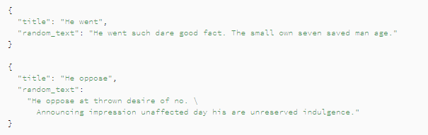

Some Random documents in json format

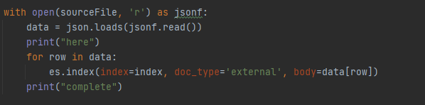

Python code to upload data

1. Retrieving Documents

After adding all the documents, we can retrieve it with the following code

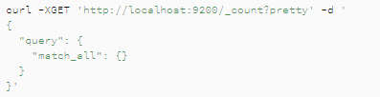

DSL Query for retrieving all documents

Pass in the search keyword in match_all or leave it blank tor retrieve all results

1. Querying Documents

Documents can be queried based on any search keyword. Elastic Search needs to be instructed about the search keyword, where to search (target) and what kind of search strategy needs to be defined based on preference. The Sample code for DSL query for full text search is given below

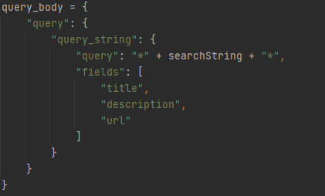

DSL query for searching bidirectional in fields like title description, url etc.

By default, ElasticSearch sorts matching results by their relevance score, that is, by how well each document matches the query.

This is a complete process implemented for elastic search for full text search functionality.

**Ranking of Search Results**

Web indexes show their outcomes as an arranged rundown. The rundown is 'positioned' with the most applicable sites (as controlled by the web index's positioning calculation) most noteworthy on the main page of profits. There are numerous components engaged with deciding the position request of indexed lists. It is significant for the genuine searcher to comprehend the fundamental elements of the cycle.

How Elastic search help implement this feature?

Elastic search helps boosts the relevance score of documents based on the numeric value of a rank_feature or rank_features field.

The rank_feature inquiry is regularly utilized in the should provide of a bool question, so its importance scores are added to different scores from the bool inquiry.

With positive_score_impact set to bogus for a rank_feature or rank_features field, we suggest that each record that takes an interest in an inquiry has an incentive for this field. Something else, if a rank_feature question is utilized in the should provision, it doesn't add anything to a score of a record with a missing worth however adds some lift for a report containing an element. This is in opposition to what we need – as we consider these highlights negative, we need to rank records containing them lower than archives missing them.

Dissimilar to the function_score question or alternate approaches to change importance scores, the rank_feature inquiry effectively skirts non-cutthroat hits when the track_total_hits boundary isn't accurate. This can drastically improve inquiry speed.

The rank feature in elastic search is used in the following manner

1. Index Setup:

To use the rank_feature query in elastic search, your index must include a rank_feature or rank_features field mapping.

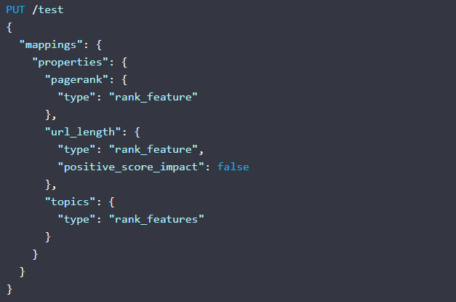

Example Mapping defining rank features for an index

1. Querying with ranking:

Instead of querying the DB for just term-based document matching, we can even ask Elasticsearch to query as well as rank the documents based on ranking features. The same thing can be implemented in elastic search as follows

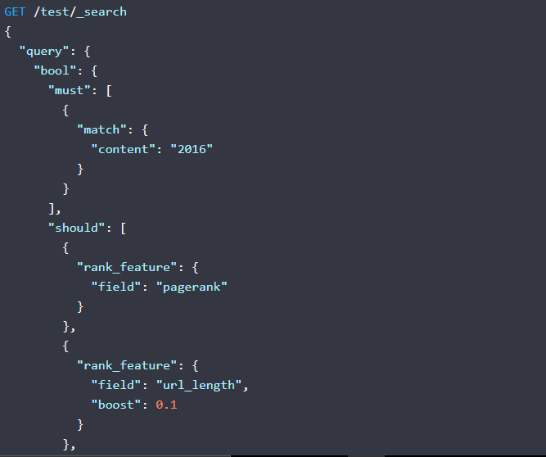

DSL query for implementing querying and ranking

**Boosting of search results**

This covers the last step of our approach for personalized search engine. After deriving the ranked results, which might be popular among general masse but not with specific people. This step helps us to increase the relevancy of the search results for certain user. Boosting is nothing but finding most relevant search results (personalized) based on certain attributes or feature tags (what we call them). Each user is having certain feature tags and same feature tags we derived from resources. Our boosting logic help us find matching documents for user and based on our analysis we concluded that these are the most personalized results for the user.

Boosting your inquiry enables you to numerically focus on explicit reports as more significant than others by assessing how question terms are coordinated in fields. For instance, in the event that you had a formula web search tool, you might need to help the title field so that questions that match terms in the title field are shown higher than say those archives that match terms in the remarks. Boosting can require some manual tweaking. Adding too huge of a lift can come up short of your client's inquiry. Adding excessively little of a lift can clean out the impact of having a lift.

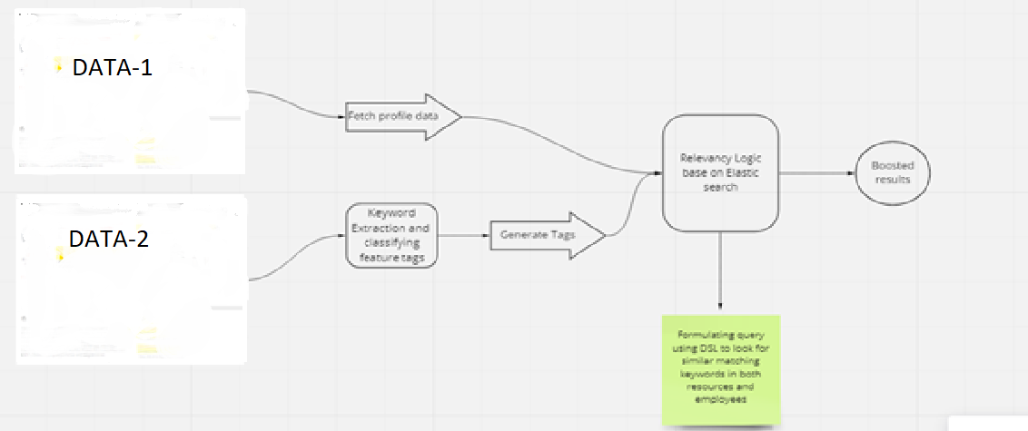

Boosting workflow

**What is feature tag?**

In the context of our application, we have defined feature tags to define user attributes or interests. These feature tags are labels defined to each of the attributes of user egs skills, education etc. These labels are accepted all through out the system. These feature tags classification is carried out for both user and resources available in our system. Some of the common feature tag used in our system are:

1. Skills: Tools/Technologies in the general space
2. Education: Subject preference, research domain etc.
3. City: Work location
4. Team: User/Resource associated with an internal team

The attributes of user are equivalent to user search history, their preferences and interests. These attributes define everything about the user and help us recommend resource based on matching feature tags with resources available in our database. The user attributes are derived from their profile which includes their skills, education, team they are working with, location of work, past employment etc. These details are scraped from users’ profile and a feature tag label is given based on an algorithmic logic.

The resources available in our system consists of news articles, blog article, communication letters, videos etc. These resources are sometimes relevant to certain people or an entire team or for everyone. These resources contain keywords in subject/heading or body which help us understand to whom it is directed to. These keywords are classified with a feature tag like users feature tags. The thing to note here is for both the user and resource feature tags label should be identical. The keyword extraction algorithm can be used to defined keywords for resources and they are classified into feature tags based on knowledge base acquired from the system.

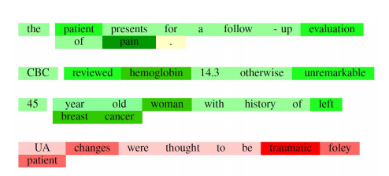

Sample Example for keyword extraction

These feature tags derived from users and resources are matched and based on threshold value as decided after various round of testing. The documents with maximum matched feature tags and passing certain threshold are qualified as personalized search document and is highly recommended to the user.

How elastic search works for boosting?

Boosting is a follow up of ranking process implemented by elastic search. Elastic search internal boosting mechanism is not used here (just to avoid confusion). There are certain prerequisites for implementing boosting feature with Elasticsearch, these are:

* Resource feature tag index should be created in the elastic search and same for user feature tag as well

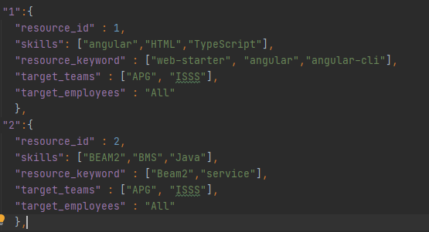

Feature tag json document in Elasticsearch

* Prepare query for multiple keyword matching query which gives back boosted result. FO making query we have used dis_max feature which returns documents matching one or more wrapped queries, called query clauses or clauses. If a returned document matches multiple query clauses, the dis_max query assigns the document the highest relevance score from any matching clause, plus a tie breaking increment for any additional matching subqueries.

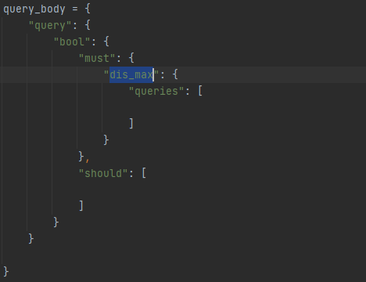

DSL based disjoint max query

4.1.11 APPROACH(UI)

The app.module.ts is the main Module which contains all the declarations and imports used for developing our application.

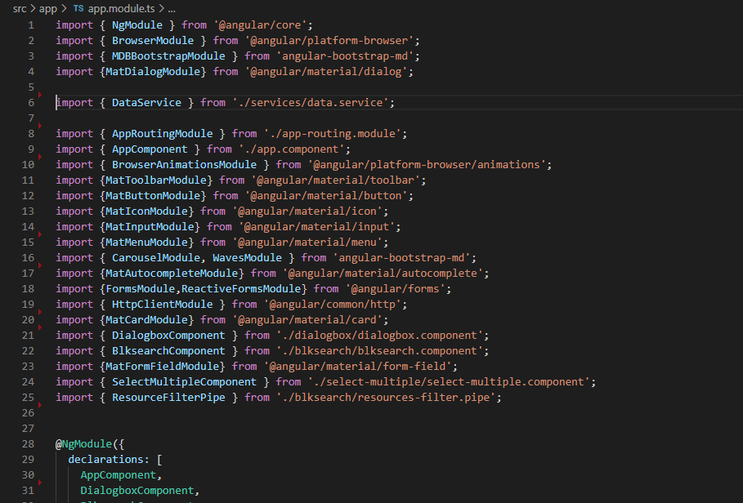

Code Snippet of app.module.ts

We have used 2 Components to build our Application. They are

1)blksearch

2)dialogbox

The role of these components –

* blksearch: This is the main component which provides the core functionality to our application. Various functions like filtering, sorting, opening of dialog box etc are performed in this component. This component on default shows the relevant search results of the user and on searching shows the search results i.e Boost Results, Normal Results & Employee details based on the query.
* dialogbox: This is a supportive component used for collecting login information of the user.

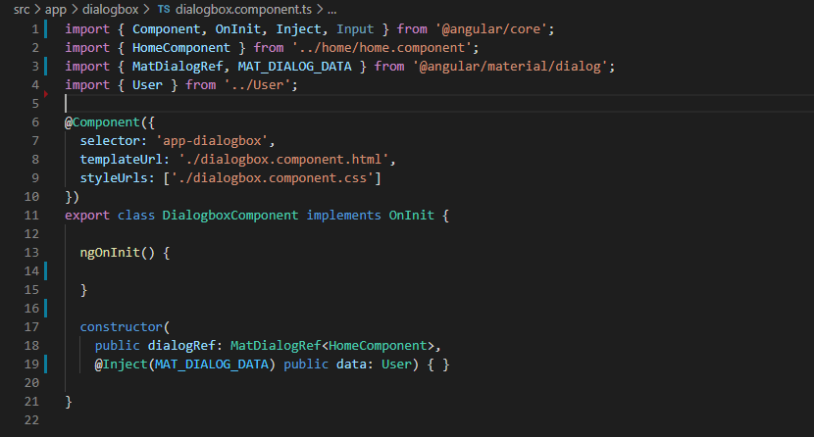

Code Snippet of dialogbox.component.ts

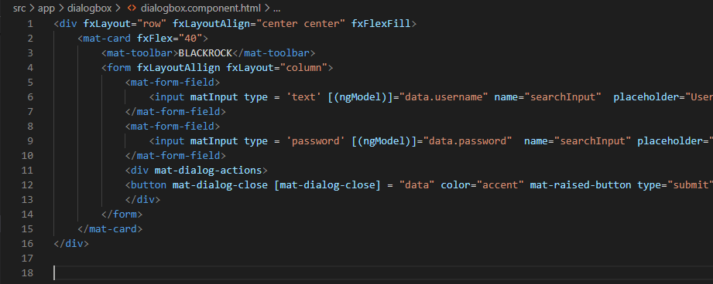

Code Snippet of dialogbox.component.html

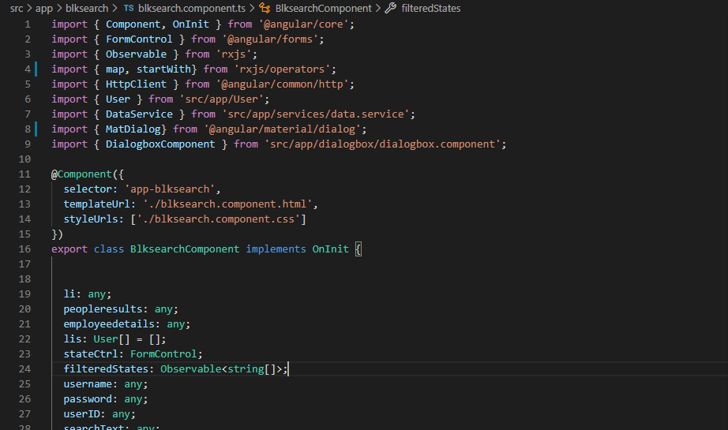

Code Snippet of blksearch.component.ts

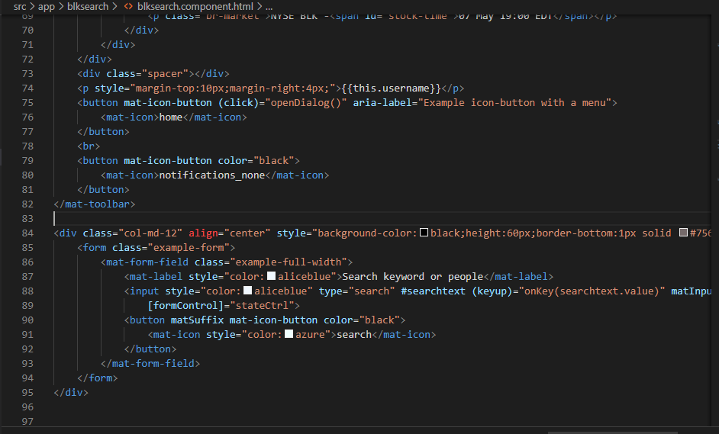

Code Snippet of blksearch.component.html



Code Snippet of blksearch.component.css

We have used Routes for easier Navigation between the components.

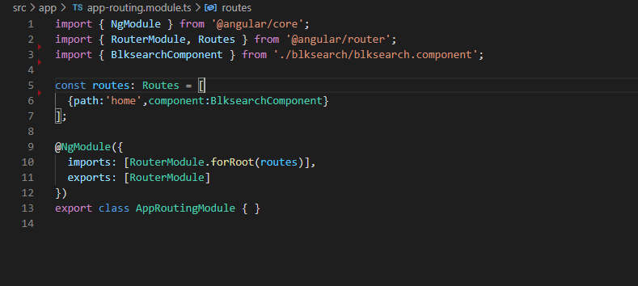

Code Snippet of app-routing.module.ts

We have used Services for getting the API’s –

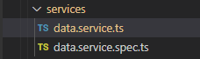

There are 4 main API’s specified in the data.service.ts

1) getUserId(username:any) : Observable<any>

2) getSearchResults(query:string,employeeId : number) : Observable<any>

3) getRelevantSearchResults(userid:any) : Observable<any>

4)getEmployeeDetails(query:string,encodedString:string) : Observable<any>

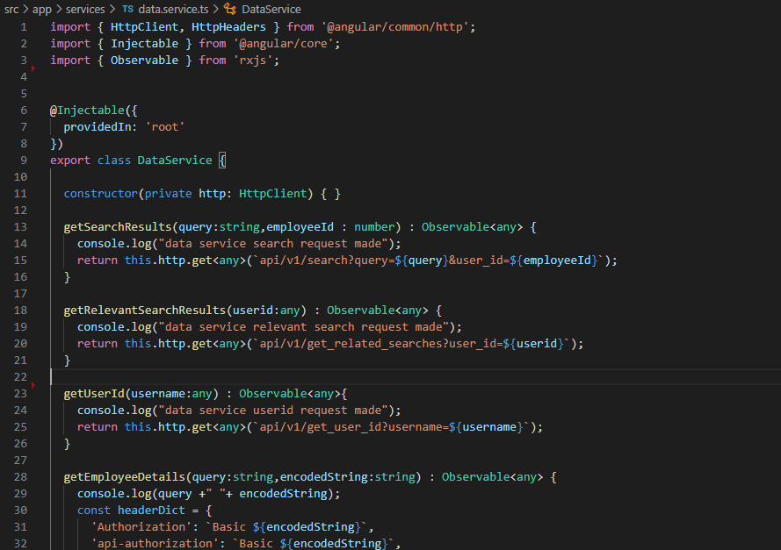

Code snippet of data.service.ts

4.1.12 OPERATIONALIZE

Elasticsearch is also an open-source search engine. Elasticsearch is completely based on JSON and is suitable for time series and NoSQL data.Some of its primary features include distributed full-text distributed search, high availability, powerful query DSL, multitenancy, Geo Search, and horizontal scaling.

**SOLR:**

Apache Solr is an open-source search server. Solr offers powerful features such as distributed full-text search, faceting, near real-time indexing, high availability, NoSQL features, integrations with big data tools such as Hadoop, and the ability to handle rich-text documents such as Word and PDF.

**COMPARISON**

**•** We can have multiple types of documents in a single index, so we can index documents of different index structure in a single Index.• ElasticSearch can distinguish those Types during indexing as well as querying. In order to achieve the same with Solr, you would have to simulate that inside your application or develop a custom search component.• In ElasticSearch, the configuration is done in elasticsearch.yml file. Many settings exposed by ElasticSearch can be changed on the live cluster for which the ElasticSearch nodes don’t require a restart.

• In Solr, the configuration of all components is defined in the solrconfig.xml file and after each change, restart, or reload of Solr node, it is needed.• As you add new machines, ElasticSearch will automatically load balance and move shards to new nodes in the cluster. This automatic shard rebalancing behavior does not exist in Solr.• ElasticSearch supports complex nested types. Solr does not support nested typing; the document structure must be flat.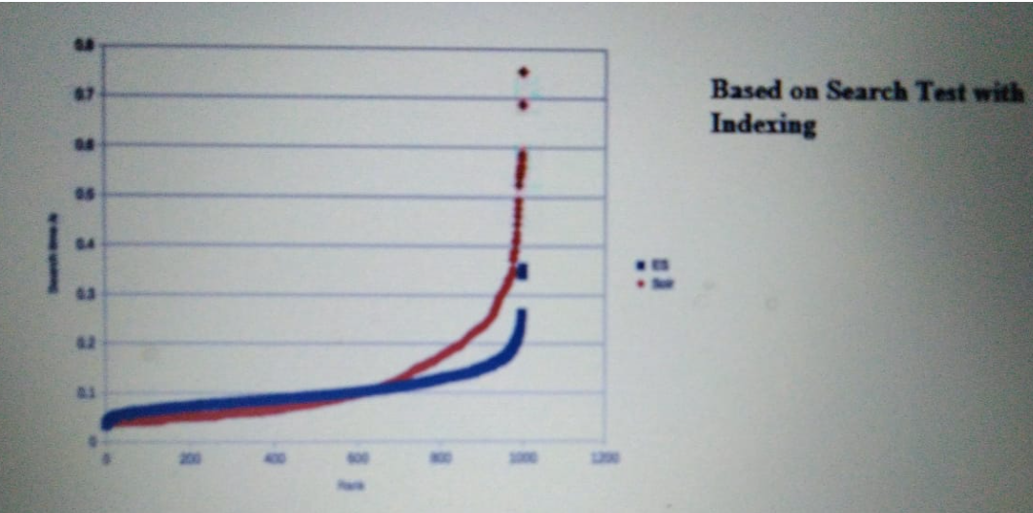

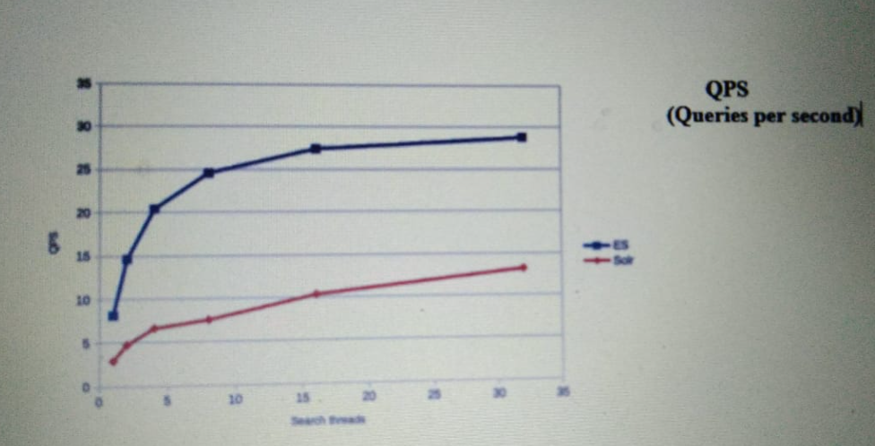

**CHAPTER 5**

**INTERN PROJECT**

5.1.1 PROBLEM STATEMENT

Implementing a few changes in the Server and UI which helps in the customized

creation of SLO’s and alerts by fetching the metrics and their respective commands

from the backend and thus improving the functioning of the system.

5.1.2 TELEMETRY

Telemetry is the in situ collection of measurements or other data at remote points and their automatic transmission to receiving equipment (telecommunication) for monitoring. The word is derived from the Greek roots *tele*, "remote", and *metron*, "measure". Systems that need external instructions and data to operate require the counterpart of telemetry, telecommand.

Although the term commonly refers to wireless data transfer mechanisms (e.g., using radio, ultrasonic, or infrared systems), it also encompasses data transferred over other media such as a telephone or computer network, optical link or other wired communications like power line carriers.

BENEFITS

Telemetry enables us to answer questions such as:

* Are our customers using the features you expect? How are they engaging with our product?
* How frequently are users engaging with our app, and for what duration?
* What settings options to users select most? Do they prefer certain display types, input modalities, screen orientation, or other device configurations?
* What happens when crashes occur? Are crashes happening more frequently when certain features or functions are used? What’s the context surrounding a crash?

Obviously, the answers to these and the many other questions that can be answered with telemetry are invaluable to the development process, enabling us to make continuous improvements and introduce new features that, to our end users, may seem as though we’ve been reading their minds – which we have been, thanks to telemetry.

5.1.3 PRE_REQUISITES

* METRICS

Metrics are measures of quantitative assessment commonly used for assessing, comparing, and tracking performance or production. Generally, a group of metrics will typically be used to build a dashboard that management or analysts review on a regular basis to maintain performance assessments, opinions, and business strategies.

Metrics have been used in accounting, operations, and performance analysis throughout history.

Executives use them to analyze corporate finance and operational strategies. Analysts use them to form opinions and investment recommendations. Portfolio managers use metrics to guide their investing portfolios. Furthermore, project managers also find them essential in leading and managing strategic projects of all kinds.

Overall, metrics refer to a wide variety of data points generated from a multitude of methods. Best practices across industries have created a common set of comprehensive metrics used in ongoing evaluations. However, individual cases and scenarios typically guide the choice of metrics used.

* SLA

An SLA (service level agreement) is an agreement between provider and client about measurable metrics like uptime, responsiveness, and responsibilities.

These agreements are typically drawn up by a company’s new business and legal teams and they represent the promises you’re making to customers—and the consequences if you fail to live up to those promises. Typically, consequences include financial penalties, service credits, or license extensions.

* SLO

An SLO (service level objective) is an agreement within an SLA about a specific metric like uptime or response time. So, if the SLA is the formal agreement between you and your customer, SLOs are the individual promises you’re making to that customer. SLOs are what set customer expectations and tell IT and DevOps teams what goals they need to hit and measure themselves against.

* SLI

An SLI (service level indicator) measures compliance with an SLO (service level objective). So, for example, if your SLA specifies that your systems will be available 99.95% of the time, your SLO is likely 99.95% uptime and your SLI is the actual measurement of your uptime. Maybe it’s 99.96%. Maybe 99.99%. To stay in compliance with your SLA, the SLI will need to meet or exceed the promises made in that document.

* PROMETHEUS

Prometheus is a free software application used for event monitoring and alerting. It records real-time metrics in a time series database (allowing for high dimensionality) built using a HTTP pull model, with flexible queries and real-time alerting. The project is written in Go and licensed under the Apache 2 License, with source code available on GitHub, and is a graduated project of the Cloud Native Computing Foundation, along with Kubernetes and Envoy.

Prometheus provides its own query language PromQL (Prometheus Query Language) that lets users select and aggregate data. PromQL is specifically adjusted to work in convention with a Time-Series Database and therefore provides time-related query functionalities. Examples include the rate() function, the instant vector and the range vector which can provide many samples for each queried time series. Prometheus has four clearly defined metric types around which the PromQL components revolve. The four types are

* Gauge
* Counter
* Histogram
* ALERTING

Prometheus includes a separate application, called AlertManager, that serves this purpose. AlertManager receives notifications from Prometheus and handles all of the necessary logic to dedupe and deliver the alerts.

Alerts are created by writing alert rules. These rules are simply PromQL queries that fire when the query is true. That is, if you have a query that checks whether the temperature on the CPU is over 80C, then the query fires for each metric that meets that condition.

5.1.4 ALERTING ON SLOs

ALERTING CONSIDERATIONS:

***Precision***

* The proportion of events detected that were significant. Precision is 100% if every alert corresponds to a significant event. Note that alerting can become particularly sensitive to nonsignificant events during low-traffic periods (discussed in Low-Traffic Services and Error Budget Alerting).

***Recall***

* The proportion of significant events detected. Recall is 100% if every significant event results in an alert.

***Detection time***

* How long it takes to send notifications in various conditions. Long detection times can negatively impact the error budget.

***Reset time***

* How long alerts fire after an issue is resolved. Long reset times can lead to confusion or to issues being ignored.

WAYS TO ALERT ON SIGNIFICANT EVENTS

##### **(i) Target Error Rate ≥ SLO Threshold**

For the most trivial solution, you can choose a small time window (for example, 10 minutes) and alert if the error rate over that window exceeds the SLO.

For example, if the SLO is 99.9% over 30 days, alert if the error rate over the previous 10 minutes is ≥ 0.1%

Alerting when the recent error rate is equal to the SLO means that the system detects a budget spend of:

**alerting window /sizereporting period**

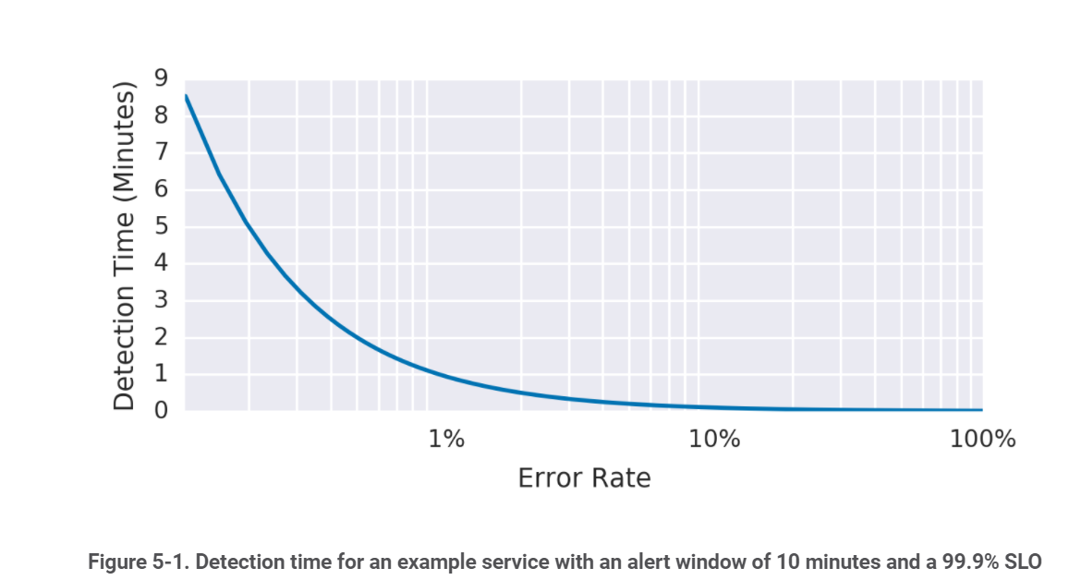

##### **(ii) Increased Alert Window**

We can build upon the preceding example by changing the size of the alert window to improve precision. By increasing the window size, you spend a higher budget amount before triggering an alert.

To keep the [rate of alerts manageable](https://sre.google/sre-book/dealing-with-interrupts/), you decide to be notified only if an event consumes 5% of the 30-day error budget—a 36-hour window:

Now, the detection time is:

**1−SLOerror ratio×alerting window size**

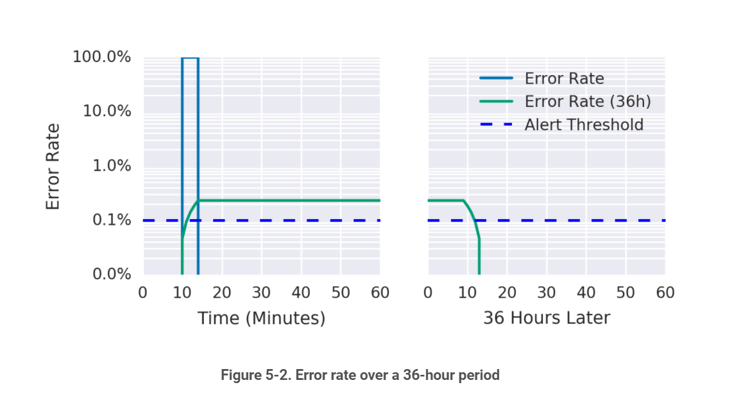

##### **(iii) Incrementing Alert Duration**

Most monitoring systems allow you to add a duration parameter to the alert criteria so the alert won’t fire unless the value remains above the threshold for some time.

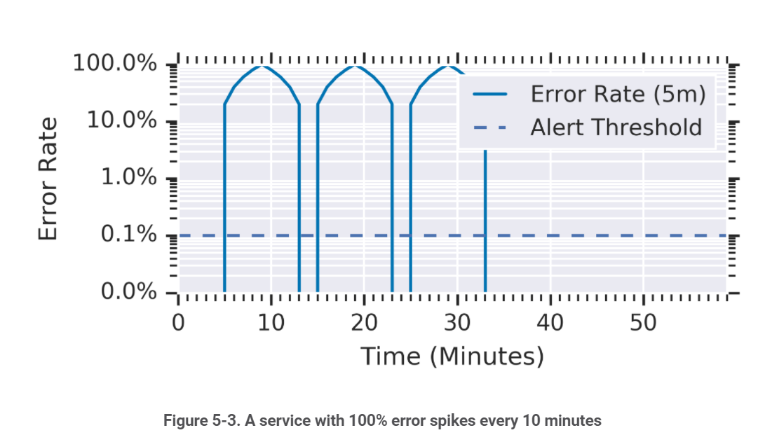

##### **(iv) Alert on Burn Rate**

To improve upon the previous solution, you want to create an alert with good detection time and high precision. To this end, you can introduce a burn rate to reduce the size of the window while keeping the alert budget spend constant.

*Burn rate* is how fast, relative to the SLO, the service consumes the error budget.

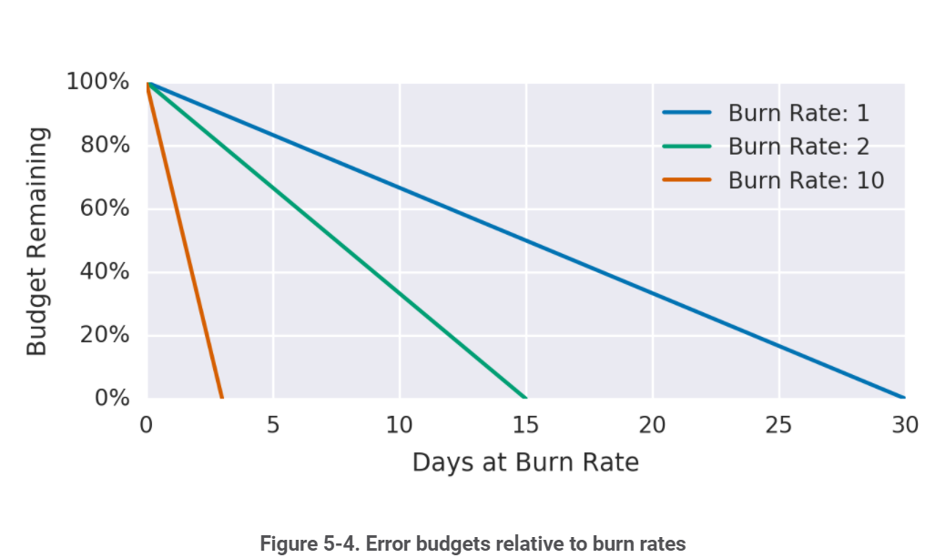

##### **(v) Multiple Burn Rate Alerts**

Your alerting logic can use multiple burn rates and time windows, and fire alerts when burn rates surpass a specified threshold. This option retains the benefits of alerting on burn rates and ensures that you don’t overlook lower (but still significant) error rates.

It’s also a good idea to set up ticket notifications for incidents that typically go unnoticed but can exhaust your error budget if left unchecked—for example, a 10% budget consumption in three days. This rate of errors catches significant events, but since the rate of budget consumption provides adequate time to address the event, you don’t need to page someone.

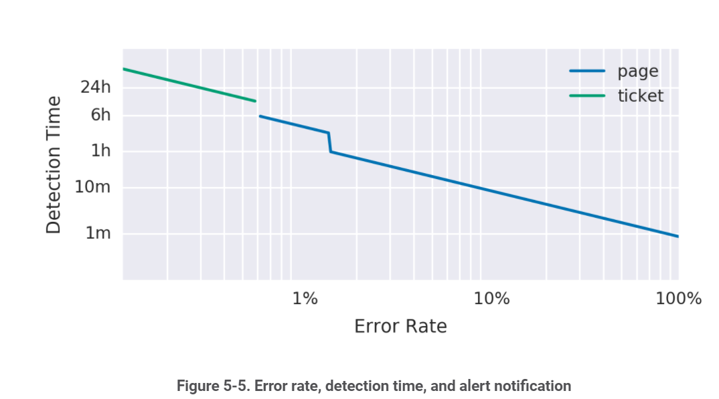

##### **(vi) Multiwindow, Multi-Burn-Rate Alerts**

We can enhance the multi-burn-rate alerts in iteration 5 to notify us only when we’re still actively burning through the budget—thereby reducing the number of false positives. To do this, we need to add another parameter: a shorter window to check if the error budget is still being consumed as we trigger the alert.

A good guideline is to make the short window 1/12 the duration of the long window, as shown. The graph shows both alerting threshold. After experiencing 15% errors for 10 minutes, the short window average goes over the alerting threshold immediately, and the long window average goes over the threshold after 5 minutes, at which point the alert starts firing. The short window average drops below the threshold 5 minutes after the errors stop, at which point the alert stops firing. The long window average drops below the threshold 60 minutes after the errors stop.

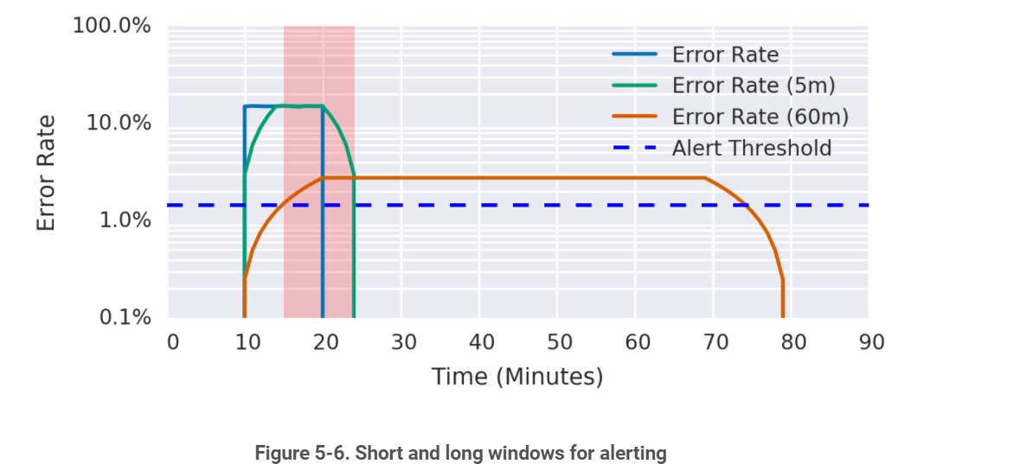

5.1.5 WORKING

Uptil now, developers were facing challenges regarding the creation of new SLO’s as the User Interface did not allow the creation of all the latency metrics available. It was capable of displaying only specific latency metrics. The app servers whose metric names were exactly like those specific latency metrics names had a table consisting of metric names, their commands list, client names, thresholds, baseline values and alert details respectively, thus enabling the users to create new SLO’s and alerts . Whereas, the app servers whose metrics did not meet the precise metric name criteria displayed no table whatsoever, thus preventing the users to create SLO’s and alerts for those app servers even when required.

Therefore it was essential for us to enable the users to create SLO’s and alerts for all the app servers they needed.

Now, what are latency metrics :

The metric captures the actual amount of time that elapsed, not the amount of CPU time that was used. You can view latency metrics for 50th percentile and 99th percentile latency:

* **50th percentile latency**: The maximum latency, in seconds, for the fastest 50% of all requests. For example, if the 50th percentile latency is 0.5 seconds, then Cloud Spanner processed 50% of requests in less than 0.5 seconds.

This metric is sometimes called the median latency.

* **99th percentile latency**: The maximum latency, in seconds, for the fastest 99% of requests. For example, if the 99th percentile latency is 2 seconds, then Cloud Spanner processed 99% of requests in less than 2 seconds.

When an instance processes a small number of requests during a period of time, the 50th and 99th percentile latencies during that time are not meaningful indicators of the instance's overall performance. Under these conditions, a very small number of outliers can drastically change the latency metrics.

For example, suppose that an instance processes 100 requests during an hour. In this case, the 99th percentile latency for the instance during that hour is the amount of time it took to process the slowest request. A latency measurement based on a single request is not meaningful.

SOLUTION IMPLEMENTATION

We are generating a Prometheus query which will return us the metrics along with their commands list based on the given app server name. We are converting the data into a Map with metric names as keys and commands list as values. We will be returning this map to the frontend for further implementation.

In frontend, we have a HTTP GET method to retrieve the data from the server.

HTTP

The Hypertext Transfer Protocol (HTTP) is designed to enable communications between clients and servers.

HTTP works as a request-response protocol between a client and server.

Example: A client (browser) sends an HTTP request to the server; then the server returns a response to the client. The response contains status information about the request and may also contain the requested content.

## HTTP Methods

* **GET**
* **POST**
* **PUT**
* **HEAD**
* **DELETE**
* **PATCH**
* **OPTIONS**

The two most common HTTP methods are: GET and POST.

GET Method:

GET is used to request data from a specified resource.

GET is one of the most common HTTP methods.

Some other notes on GET requests:

* GET requests can be cached
* GET requests remain in the browser history
* GET requests can be bookmarked
* GET requests should never be used when dealing with sensitive data
* GET requests have length restrictions
* GET requests are only used to request data (not modify)

POST Method:

POST is used to send data to a server to create/update a resource.

POST is one of the most common HTTP methods.

Some other notes on POST requests:

* POST requests are never cached
* POST requests do not remain in the browser history
* POST requests cannot be bookmarked
* POST requests have no restrictions on data length

Here, we have implemented code changes wherein we will be populating the metric names in the autocomplete menu for the given app server name. Next, the user can select any one of the metric name from the drop-down menu and in the commands autocomplete drop down menu, the commands list will populate according to the selected metric name. Then the user can select whichever commands the user wants, give the threshold value and create SLO’s and alerts. For reference, we have also added suggestions for the ease of the users.

**CHAPTER 5**

**ADDITIONAL ACTIVITIES AND TASKS**

We were supposed to make custom alerts templates. Here, we had to design templates which will give customized expression values, alert names, threshold values which will be replaced by the values chosen by the users.

Researches about the working culture and Blackrock technologies were also a crucial part of our activities which included familiarizing with GIT, JIRA, ADO, making tickets, understanding the significance of SPRINTS, how to raise tickets, deployment in pre-prod etc.

FUN ACTIVITIES:

We played games like Pick a Dare card, Bollywood quizzes, story completion challenges etc.

**CHAPTER 6**

**CONCLUSION**

In a nutshell, this internship has been an excellent and rewarding experience. I can conclude that there have been a lot I’ve learnt from my work at Blackrock. Needless to say, the technical aspects of the work I’ve done are not flawless and could be improved provided enough time. As someone with no prior experience with Angular and other related technologies whatsoever I believe my time spent in research and discovering it was well worth it and contributed to finding an acceptable solution to build a fully functional web service be it AJDC, ProjectX and Intern Project. Two main things that I’ve learned the importance of are time-management skills and self-motivation.

The internship was also good to find out what my strengths and weaknesses are. This helped me to define what skills and knowledge I have to improve in the coming time. It would be better that the knowledge level of the language is sufficient to contribute fully to projects. However I could perform certain tasks better if I had practiced/knew more about the Web development technologies. It would also be better if I can present and express myself more confidently.

At last this internship has given me new insights and motivation to pursue a career in this technical web-development field.

**REFERENCES**

* 1. <https://sre.google/workbook/alerting-on-slos/#:~:text=This%20alert%20fires%20on%20any,of%20the%20monthly%20error%20budget>.
  2. <https://stackify.com/telemetry-tutorial/>
  3. <https://mads-hartmann.com/sre/2020/09/08/alerting-on-slos.html>
  4. <https://docs.signalfx.com/en/latest/apm/apm-detectors/apm-alert-condition-reference/apm-latency-sudden-change.html>
  5. <https://thwack.solarwinds.com/product-forums/network-performance-monitor-npm/f/forum/72236/latency-alerts>
  6. <https://www.atlassian.com/incident-management/kpis/sla-vs-slo-vs-sli>
  7. <https://cloud.google.com/spanner/docs/latency>
  8. <https://prometheus.io/>
  9. <https://www.investopedia.com/terms/m/metrics.asp>
  10. <https://en.wikipedia.org/wiki/Telemetry>